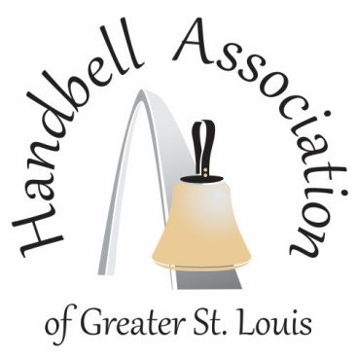
spRingfest – 2023
Please join fellow ringers for a one day workshop filled with learning, laughter and new friends. We will be ringing five massed pieces.

Guest Conductor – Nick Hanson
Nick Hanson received a Bachelor of Arts degree from Concordia University, Irvine, California, as a major in music with a concentration in handbells. He has been on faculty at the Potomac School in McLean, Virginia, for over 15 years, where he teaches handbells to 5th–12th grade students in five different handbell ensembles. He is also the handbell director at Bush Hill Presbyterian Church in Alexandria, Virginia.

Nick has served as faculty, clinician, and conductor at handbell events in 19 states (and Washington, DC) as well as internationally in Hong Kong, Taiwan, and Singapore. In 2015, Nick was chosen as the first-ever Associate Conductor for Distinctly Bronze under the mentorship of renowned conductor Dr. William A. Payn. Also in 2015, Nick conducted the Distinctly Teen ensemble at the Handbell Musicians of America National Seminar in Dallas, Texas. Most recently, Nick was the 2018 guest foreign conductor for the “Showtime” concert performed by Ministry of Bellz, the premier handbell ensemble of Singapore. He has written articles for the Overtones national handbell magazine as well as arranged and composed many pieces of handbell music.

Who May Attend?
Full choirs, partial choirs and individuals are invited to attend.

What Should We Bring?
Full and partial choirs must bring EVERYTHING – handbells, chimes, tables, pads with covers, notebooks, mallets, etc. Tables are available for rental – see registration form. If registering as an individual, you should bring a notebook, music selections and gloves. Handbells and chimes will be available for your use.

Schedule:
INCLEMENTWEATHER
We will be monitoring the weather conditions very closely. Understanding some people will be driving a great distance, we will try to make a decision by noon on Friday. Information will be posted on our website and an email will be sent to all registered.
8:00 – 8:45 Setup; Introductions at 8:45
9:00 – 10:15 Session I
10:15 – 10:30 Break
10:30 –11:45 Session II
11:45 – 12:45 Lunch (catered at church)
12:45 – 1:30 Seminar with the guest director
1:30 – 2:30 Session III
2:30 BREAK
3:00 Public Concert

