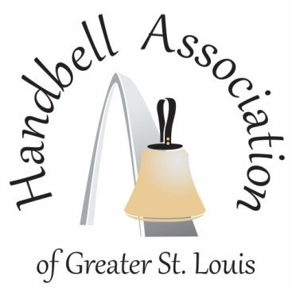
Jumpstart into Fall and
Music Reading Session
August 24, 2024
Peace Lutheran Church, 737 Barracksview Road
St. Louis, MO 63125

Join us for this exciting event to Jumpstart your new ringing year! Bring your entire choir, half your choir or just yourself. This event will offer several classes to choose from to learn new skills, free music that you will learn and be able to use in your church, and a reading session to play through newly published repertoire.

There will be numerous gift drawings during the event and the grand prize will be a paid registration for spRingfest 2025 featuring guest clinician Brenda Austin.

Handbell 'goodies', new music and HAGSTL garage sale items will be available for
purchase.

You won't want to miss participating in this Jumpstart event!
FEES:

Early Bird Registration by Friday, August 2:
Individual fee $20 per person
Choir fee (5 or more) $100 per choir
Lunch fee (optional) $10 per person
(if you prefer, you may bring your own lunch)

Registration after August 2:
Individual fee $30 per person
Choir fee (5 or more) $150 per choir
Lunch fee $10 per person
(if you prefer, you may bring your own lunch)

Schedule:

9:30 Arrival
10:00 Reading session 1
11:00 Break
11:15 Class Session 1
12:00 Lunch Break
1:00 Class Session 2
1:45 Break
2:00 Reading Session 2
3:00 Wrap up/ door prizes
3:30 Finish

